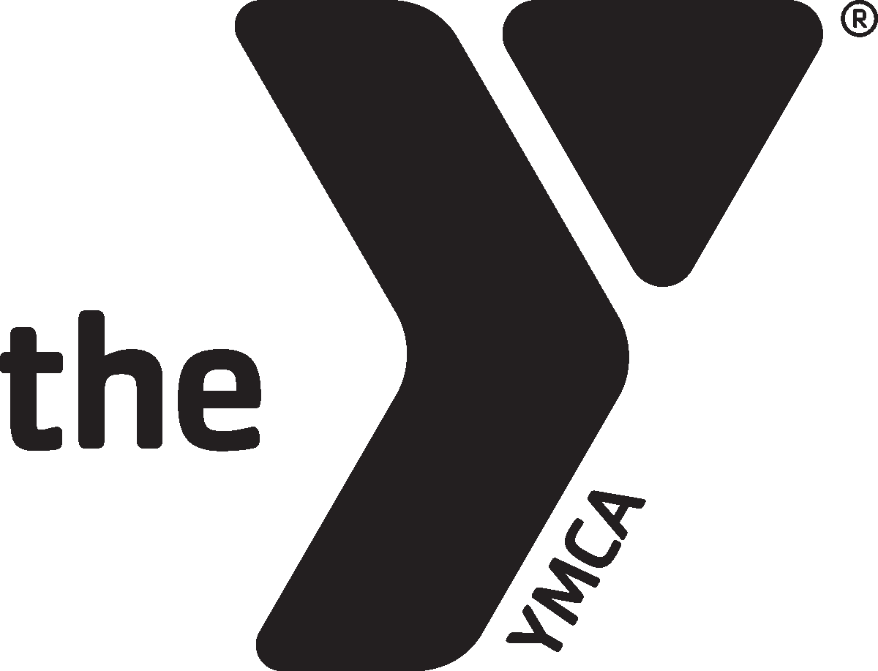

**ASHLAND YMCA POOL SCHEDULE**

**WATER FITNESS**

***\*\*\*EAST POOL\*\*\****

**MONDAY Aquacise**

9:00-10 am

**TUESDAY Arthritis**

9:00-10 am

**WEDNESDAY Aquacise**

9:00-10 am

**THURSDAY Arthritis**

9-10 am

**FRIDAY** **Aquacise**

9:00-10 am

*class times and instructors are subject to change based on special swim programs and availability

**Hours Effective December 4th-22nd**

**WEST POOL CLOSED DECEMBER 4TH @ 10AM**

EAST POOL WEEKEND HOURS

**SATURDAY**

7:30 – 9 am Shared Lap Swim

11 am -3 pm FAMILY OPEN SWIM

**SUNDAY**

1:00-4:00 pm Family Open Swim

**EAST POOL**

**LAP/OPEN SWIM TIMES**

**MONDAY**

5:45-9 am LAP/ ADULT OPEN SWIM

10:30-1pm LAP/OPEN

5:15-6:30pm LAP/FAMILY OPEN

**TUESDAY**

5:45-9 am LAP/ADULT OPEN SWIM

10:30-1pm LAP/OPEN

5:15-6:30pm LAP/FAMILY OPEN

**WEDNESDAY**

5:45-9 am LAP/ADULT OPEN SWIM

10:30-1pm LAP/OPEN

5:15-6:30pm Shared Lap Swim

**THURSDAY**

5:45-9 am LAP/ADULT OPEN SWIM

10:30-1pm LAP/OPEN

5:15-6:30pm Shared Lap Swim

**FRIDAY**

5:45-9 am LAP/ADULT OPEN SWIM

10:30-1pm LAP/OPEN

5:15 pm-6:30pm Shared Lap Swim

***Additional Information***

**\*Any child under the age of 13 must take a swim test in order to enter the deep end of the pool.**

**\*6 & Under must be accompanied by an adult 18 years or older.**

**\*Swim Lessons will be offered Monday and Tuesday evenings.**

**\*Private lessons are also available.**

**Please see brochure or website for all information.**

**Schedule Effective**

**December 2019**

**EAST POOL: 10 ft depth**

**25 Meters, 6 Lanes**

**66 laps to a mile**

**Ashland YMCA**

**207 Miller Street**

**419-289-0626**

**aquatics@ashlandy.org**

**WEST POOL; 9 FT. depth**

**20 Yards, 4 Lanes**

**84 laps to a mile**