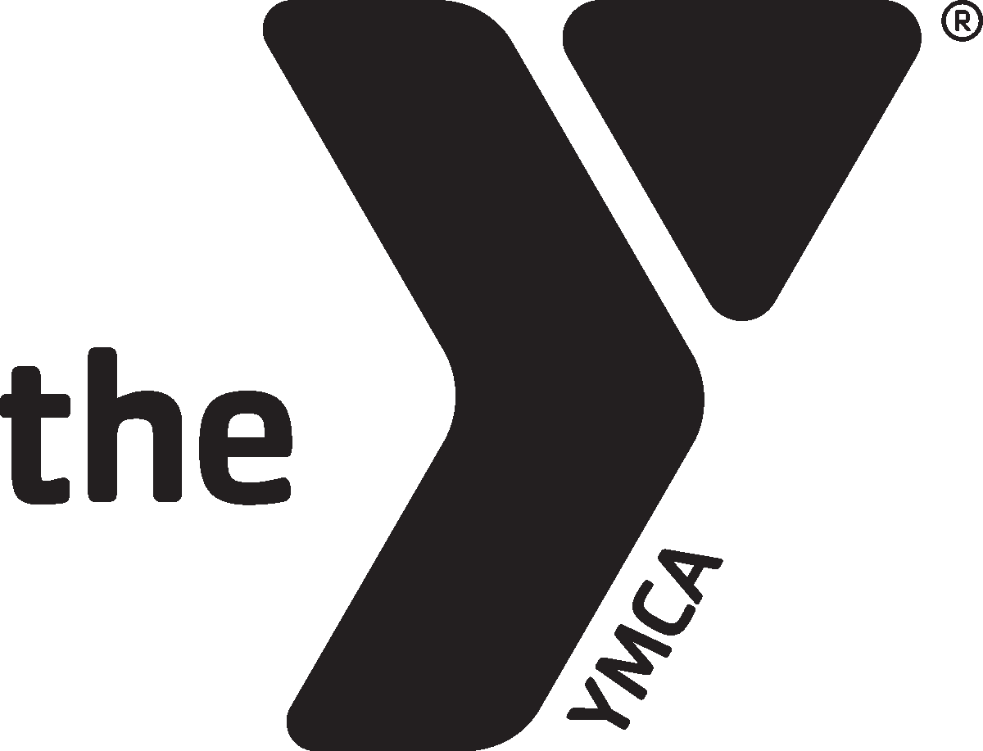

**ASHLAND YMCA POOL SCHEDULE**

**WATER FITNESS**

***WEST POOL***

**MONDAY Aquacise**

9-10 am

**TUESDAY Arthritis**

9-10 am (Cindy)

**WEDNESDAY Aquacise**

9-10 am

4:15-5:00pm (Christine)

**THURSDAY Arthritis**

9-10 am (Cindy)

**FRIDAY** **Aquacise**

9-10 am

*class times and instructors are subject to change based on special swim programs and availability

**WEST POOL**

***ADULT OPEN***

**MONDAY**

7:45-9:00 am

10:35 am-12:00 pm

**TUESDAY**

7:45-9:00 am

10:35 am-12:00 pm

**WEDNESDAY**

7:45-9:00 am

10:45 am-12:00 pm

**THURSDAY**

7:45 am-9:00 am

10:35 am-12:00 pm

**FRIDAY**

7:45 am-9:00 am

10:35 am-12:00 pm

***FAMILY OPEN SWIM***

**MONDAY**

12:00-1:00 pm

5:30-7:30 pm

**TUESDAY**

12:00-1:00 pm

5:30-7:30 pm

**WEDNESDAY**

12:00-1:00 pm

5:00-8:00 pm

**THURSDAY**

12:00–1pm

5:00-8:00 pm

**FRIDAY**

12:00 pm-1:00 pm

4:45 pm-6:30 pm

**SATURDAY**

11:00 am – 3:00pm

**SUNDAY**

1:00 pm – 4:00 pm

**Rental Jan 25th 11am-12pm**

**Saturday open swim subject to change due to rentals, please call for updates.**

**EAST POOL**

**Lap Swimming**

**Monday**

5:45 – 7:30 am

10:30-12:30 pm

5:15-6:30 pm (share with HS)

**Tuesday**

5:45 – 7:30 am

10:30-12:30 pm

5:15-6:30 pm (share with HS)

**Wednesday**

5:45 – 7:30 am

10:30-12:30 pm

5:15-6:30 pm (share with HS)

**Thursday**

5:45 – 7:30 am

10:30-12:30 pm

5:15-6:30 pm (share with HS)

**Friday**

5:45 – 7:30 am

10:30-12:30 pm

5:15-6:30 pm (share with HS)

**Saturday**

7:30-9 am (share with HS)

The East pool is for lap swimming and private lessons only. Please move up and down the lanes continuously.

**Pool Hours are subject to change.**

***Additional Information***

**\*Any child under the age of 13 must take a swim test in order to enter the deep end of the pool.**

**\*6 & Under must be accompanied by an adult 18 years or older.**

**\*Swim Lessons will be offered Monday and Tuesday evenings.**

**\*Private lessons are also available.**

**Please see brochure or website for all information.**

**Schedule Effective**

**January 2020**

**EAST POOL: 10 ft depth**

**25 Meters, 6 Lanes**

**66 laps to a mile**

**Ashland YMCA**

**207 Miller Street**

**419-289-0626**

**aquatics@ashlandy.org**

**WEST POOL; 9 FT. depth**

**20 Yards, 4 Lanes**

**84 laps to a mile**