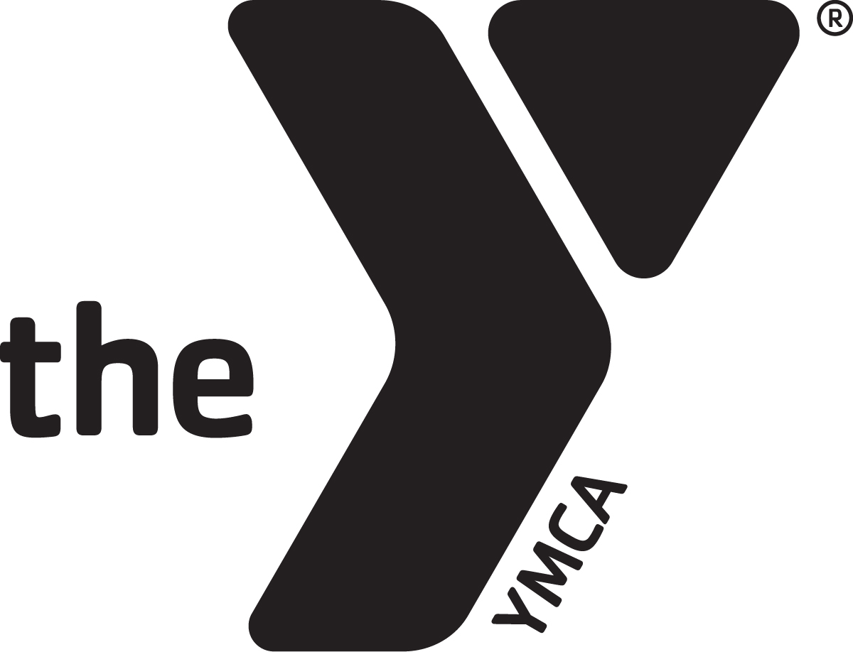

ASHLAND YMCA PRESCHOOL

Welcome to the YMCA Preschool! The registration packet has several important documents that must be completed in full for your child to participate in our program. Be sure to answer each question completely, no matter how repetitive they may seem. ALL forms, fees (including outstanding bills) and information MUST be complete before your child can be accepted. If the form does not apply to your child, please put your child's name on it and sign with some indication that it does not pertain to you. To receive the member price, you MUST have proof of membership or Partner with Youth eligibility. The registration fee is $25 dollars until June 15 and then increases to $40. The registration fee is non-refundable. After completion of the registration materials, make arrangements with the administrator to review your paperwork and the registration process will be finalized at that time. You will receive updates by way of email about important dates and materials, so please be sure to include an email address for me to send things to. I promise I will not sell your information or give it to anyone without your consent. If you have any questions, please feel free to contact me. I am so excited for our new year to begin and look forward to meeting all of your families!

Most sincerely,
Christie Krumlaw
Christie Krumlaw
Ashland YMCA Preschool Coordinator
ckrumlaw@ashlandy.org
419-289-0626

PLEASE NOTE: The fees for families attending All Day Care have been raised to account for breaks and snow days, that amount has not been accounted for in the half day or full day preschool prices. If you attend All Day Preschool and will need care on these days there will be a $25 member or $35 community fee and advance notice needed. If you show up the day of, without previous arrangements, it will cost an additional $10

Ashland YMCA Preschool Registration
School year enrolling_2019/2020_

Will your child attend kindergarten in the next school year___YES___NO
(must be 5 by no later than September 30th for Ashland, Black River and Wooster and August 1st for Hillsdale, Mapleton, Ashland Christian, Crestview, Loudonville, and Northwestern, June 1st for St. Ed's)

Is your child a member of the YMCA___YES___NO Expiration Date________

Child's Full Name____________________________________________________
(FIRST, MIDDLE AND LAST)

Birthdate__________________Age of child upon enrollment________

Address__________________________________________________

City____________________________________Zip_______________

Email Address_____________________________________________

Cell Phone for Alerts________________________________________

Mother/Guardian___________________________________________

Phone(home)________________________(work)________________

Father/Guardian___________________________________________

Phone(home)________________________(work)________________

Preschool hours are 8:30-11 or 8:30-3. Preschool follows the Ashland City School schedule. To be considered for care over holidays or snow/delay days you must sign up for All Day Care. All Day Preschool may attend with an additional fee that is stated later in the information.
**A non-refundable registration fee of $25 must accompany this form before June 15. After this date the registration fee of $40 (non-refundable) must accompany this form. You must have a membership to receive member pricing.**

Child's Name___________________________________
Days and Times:
Mon___________Tues___________Wed__________Thur__________Fri__________ IN/OUT IN/OUT IN/OUT IN/OUT IN/OUT

ALL DAY CARE (includes Preschool) 6:30am-6pm
 | Member | Non member | Total
5 all day | $500 | $600
4 all day (Mon-Thu) | $410 | $515
3 all day (Mon, Wed, Fri) | $320 | $440
2 all day (Tue, Thu) | $275 | $400

Will your child require a nap on the days they attend ______yes_____no (please check one)

ALL DAY PRESCHOOL 8:30am-3pm
 | Member | Non member | Total
5 all day | $390 | $440
4 all day (Mon-Thu) | $320 | $365
3 all day (Mon, Wed, Fri) | $260 | $305
2 all day (Tue, Thu) | $220 | $265

Will your child require a nap on the days they attend ______yes_____no (please check one)

HALF DAY PRESCHOOL 8:30am-11am
 | Member | Non member | Total
5 day AM/PM Preschool | $205 | $300
4 day AM/PM Preschool | $165 | $230
3 day AM/PM Preschool | $135 | $200
2 day AM/PM Preschool | $115 | $175

Total to be paid MONTHLY_______________

Parent Signature____________________________________Date_______

_____(Initial) I would like to have my payments paid through Scheduled Payments and will file proper paperwork with the Preschool Coordinator. I understand that I must have a membership to the YMCA for this to be an option.

Financial Agreement
I agree to pay the Ashland YMCA Preschool the stated amount of tuition indicated for my child's care. Tuition is due September through May. A two week notice of withdrawal is required from preschool. To receive the member rate, I understand that my child must be an active member. Tuition is due monthly by the first week of each month, and a late fee of $20 will be assessed after the 10th of that month. If I am a JFS family I will have all proper paperwork completed before attendance begins and will keep up on my swipes to receive these benefits. If I am more than 10 days behind on swipes, I agree that I will self pay for the time that has been used.

*Parent/Guardian Signature_____________________________Date______

Administrator Signature_______________________________Date_______

Swimming, Gymnastics and Walking Field Trip Permission
Please check all that apply:
____My child has my permission to participate in the YMCA swimming program. The center will have two supervising staff and a certified life guard on duty at all times.
____ My child also has permission to participate in gymnastics lessons and activities. Children will be supervised and assisted during lessons, to maintain a safe and healthy environment.
____The YMCA preschool will go on walking trips, weather permitting, within a two block radius. Children will be taught safety while on the walking trips, under the supervision of classroom staff. During walking trips children will not be near water more than two feet.
*Parent signature _______________________________Date____________ Parent notes or relevant information regarding these activities:______________________
_______________________________________________________________________

I do not give permission to participate in any of the activties listed above
*Parent signature _______________________________Date____________

Assessment Permission and Authorization
The children will be assessed at least three times throughout the school year for academic gains and will do developmental assessments using Ages and Stages Questionnaire and other methods a minimum of once a year. I give permission for the teachers to perform such assessments and share the information with us and the school they will attend upon leaving the Ashland YMCA Preschool.

*Parent/Guardian Signature_____________________________Date______

Ashland Family YMCA Preschool
Emergency Pickup Information
Persons authorized to pick up child from school other than custodial parent: Must name AT LEAST one.

Child’s Name _____________________________________________________________

Child’s birthdate _________________ Email_____________________

Address _______________________________________________

Parent who should be contacted FIRST (name of parent) _____________ NUMBER to be called during the day _________________

Person to contact SECOND/relationship/phone

______________________________________________
Authorized pick up individuals:
Name Relationship Phone

1.____________________________________________________________

2.____________________________________________________________

3.____________________________________________________________

4.____________________________________________________________

Roster Permission
The State of Ohio requires preschools to have a roster of all children enrolled in preschool. HOWEVER, the only thing I need to have on it is the child’s name. I make a roster of parent’s names, phone, address and email for your convenience. You are welcome to use this info to invite children to play or for party invitations. We do not use it to solicit or harass our families. You can choose what information you wish to share; all or just a few things

Pick what you wish to be listed on roster:

_____ Mom’s name ______ Dad’s name _____ Email _____Future School System

_____ Address _____ Phone _____ Child’s birthday

Handbook Acknowledgment
Parents, after reading the handbook, please sign and return this page to the director. This is due before the child attends the center. Please feel free to ask the director any questions about the policies in the handbook.
I acknowledge that I have received a copy of the parent handbook for the Ashland Family YMCA Preschool. I agree to follow all policies outlined within.

__________________________________ _________________
Signature of parent/guardian Date

___________________________________ _________________
Signature of parent/guardian Date
*The handbook is on our website to read. If you would like, a hard copy can be provided upon request.

Photo Release
The Ashland YMCA Preschoolshares photographs of classes and participants on our easysite web-site to show families what we do all day. We would like your permission to use photographs of our day on our website. If you do not grant permission, please indicate this below.

I give the YMCA permission to use photographs of my child/children on the website.

X_______________________________________Date _________

OR
I DO NOT grant permission and the YMCA may not use my photos on the website.
X_______________________________________Date________

YMCA PRESCHOOL T-SHIRTS

Every school year you may purchase matching t-shirts to wear on special days at our school. The shirts are $9.00 and cover the cost of the shirt and the printing. Please send this in with a check for $9.00 made payable to the Ashland YMCA. This is not required of the children but we will have days where they will be given the opportunity to wear the shirts as a school. Please write a separate check and give to administration for proper record keeping. This is only an option to buy until school begins in September.

----------------------------------cut here------------------------------------

Child___________________________________________

My child will need a CXS______CS ______CM______CL______

For office use only
Payment received date____________________ | T-shirt delivered  date___________________

Ashland Family YMCA Preschool
Supply list for the beginning of the year
We NEED:
Snack of your choice
Juice
Silverware (spoons especially)
5 oz. cups
Bowls/plates
Napkins
Clorox Wipes
Tissues
Paper towels

If you WANT:
Markers
Dry Erase markers
Colored Pencils
Pencils
Crayons
Pink erasers

Preschool Scheduled Payment Authorization/Agreement

I___________________authorize my bank to make payment to the Ashland YMCA by method indicated below, and post it to my account for my child, _______________'s care at the Ashland YMCA Preschool.
Checking____(NOTE: for checking account authorization, and a voided check)
Mastercard____Visa____Discover____Other____
Account #_____________________Amt. Pd.____________
Routing #_______________________________________
Expiration Date____/_____
Address__________________________________________
City____________________State_____Zip______
Home Phone____________Cell Phone____________
Bank Name_______________________________________

I understand that I am in full control of my payment, and if at any time I decide to make any change or discontinue the service, I will call or write the above company. Change of payment will not effect other provisions and terms of my contract.

Signature______________________________Date_______
Staff Witness___________________________Date_______

Scheduled Payment Agreement
I UNDERSTAND that when enrolling in the Ashland YMCA Preschool using Scheduled Payment as the method of payment, I am committing to a nine month period of time for the school year, which will be taken out of my checking, savings, or credit card account monthly on the first of every month. I also understand that any outstanding payments not received within 60 days will be turned over to RBC Collection agency. Returned items or denied transactions will have a fee of $15.00 charged. Initials____

YMCA PHOTO/AUDIO VISUAL/NARRative RELEASE
I am 18 years of age or older and, if not, my parent or legal guardian has also provided their consent by signing below.
Consent & License. For my participation in activities to be conducted by the National Council of Young Men’s Christian Associations of the United States of America (“YMCA of the USA”) or any of its chartered member associations in the United States (collectively “the Y”), and collaborating third parties, I consent, now and for all time, to the making, reproduction, editing, broadcasting or rebroadcasting of:
- video film or footage of me,
- sound track recordings of me
- photo reproductions of me
- any narrative account of my experience
My consent includes a perpetual license to the Y and collaborating third-parties for the use of the above materials for publication, display, sale or exhibition in promotions, advertising, education and commercial uses. Use includes reproductions in any form and media currently existing or later conceived, adaptations and/or revisions, throughout the world in perpetuity.
I understand and agree there may be no additional compensation for this license, and I will not make any claim for payment of any kind from the Y or collaborating third-parties. I may, or may not be, identified in such licensed uses; however, my name will not be used to endorse any particular products or services.
Ownership, Confidentiality, and Shared Use. With respect to any of the above uses, I further agree:
- All works shall belong to YMCA of the USA;
- The Y has no duty of confidentiality regarding any licensed uses;
- YMCA of the USA shall exclusively own all known or later existing rights to the uses throughout the world;
- The Y and collaborating third-parties may use any video film, footage, sound track recordings and photo reproductions of me and/or my narrative account for any purpose without additional compensation to me.
Release from Liability. I agree that my consent is irrevocable. I hereby release and discharge The Y and collaborating third-parties, from any and all claims, actions, lawsuits or demands of any kind arising out of my consent, license grants, uses, or the shared uses of any works or materials referenced herein.
Signature: ____________________________________Date: __________________
Printed Name:________________________________Age: ________
Address:____________________________________________________________
___________________________________________________________________
I am the parent or legal guardian of _______________________________________. I hereby consent and grant the licenses detailed in the foregoing on behalf of my minor child.
Signature of parent or legal guardian:___________________________________________
Printed name: _______________________________________________________

Support Identification

In an attempt to provide a supportive learning environment and promote positive behaviors, we recognize supports and accommodations enable children to reach their fullest potential in a safe environment. Therefore, we have identified several types of strategies that may be helpful to participants. We also recognize that the introduction of these strategies may impact our staff to child ratio and the well being of all the children in attendance.
For all applicants, we are documenting and reviewing supports identified by the parents/caregivers as they enroll their child in the program. With this information we determine if we are capable of providing a safe and effective learning environment, we make decisions on whether we are the appropriate placement for each child who desires to enroll in the YMCA program.

*Child's Name_________________________________________needs no supports at this time. Please sign below.

*Child's Name _________________________________________is in need of the following supports and I have the documentation needed to receive these supports. Please mark appropriate supports and sign below.
_____Behavioral Supports _____Health Supports
_____Communication Supports _____Instructional Supports
_____Natural Supports _____Social Supports
_____Transition Supports _____Universal and Accessible Physical and Program Design Supports

If you have information on recent assessments in the areas listed below that would help identify appropriate strategies. Please provide documentation and sign below.
_____Behavioral Supports _____Health Supports
_____Communication Supports _____Instructional Supports
_____Natural Supports _____Social Supports
_____Transition Supports _____Universal and Accessible Physical and Program Design Supports
*Must be documented by a professional in written form prior to attendance and implementation. Please see next page for support explanation.

___________________________________ ____________________
Parent/Care Giver Signature Date

Support Definitions

Behavioral Supports- intended to minimize challenging behaviors. These behaviors are intended to communicate and when attempting to eliminate behavior child's frustration may be magnified. Professionals need to pinpoint what is being communicated and what environmental factors are contributing to the behaviors. When it is known what is communicated and contributes to the behavior positive support can be implemented to eliminate the risk of behaviors being displayed.

Communication Supports- intended to ensure the child understands thoroughly what is expected. Each intervention must be clear and purposeful in communication through verbal, nonverbal and kinesthetic feedback. Professionals will willingly communicate expectations, requests, and acceptable behavior parameters to create motivating and safe environments. The communication the child receives will assist them in being able to sort out what is important and respond to what they hear.

Health Supports- intended to accommodate physiological well-being and function at their maximum capacity. The use of proper diet, rest, pain management and sunlight exposure is managed. Use of quiet spaces to help regain composure as well as medications and physical activity levels will be monitored to support the child.

Instructional-leadership Supports- intended to support engagement. Professionals will plan and structure predictable environments to focus on strengths and goals.

Natural Supports- intended to be support from a family member whose preferences support the child. Support occurs when there are balanced meals and there are designated areas for appropriate choices.

Organizational Supports- intended to be supports given by collaborative team of professionals and care givers. An inclusive plan will be developed to support the child and a zero-tolerance approach will be taken to implement the support.

Social Supports- intended to help the child gain social competence, become aware of social expectations, gain information through interactions and exchange feelings during an experience.

Transition Supports- intended to help the child transition from one location to another or to another program. This support can also be used to move from one activity to another within the classroom.

Universal Design and Program Supports- intended to assist in designing structures for all children regardless of ability. Barriers are minimized and access is maximized by, for example, signs and checklists to cue children. Multiple engagement opportunities are offered to include children with a range of diverse abilities and skills.

Child's Name______________________________Birthdate_________
Future School System_______________________
Will attend Kindergarten in the year 20__
Child Information List
_____Registration Form
_____Registration Fee ___cash____check____pd date_____
_____YMCA Member Y or N Expiration Date________
_____Medical Statement Expiration Date_______Completed by_________
_____Child Enrollment/Health Info & Allergies (pg 1&2)
_____Page 3 & Medical Physical Care Plan
_____Family Information Sheet
_____Financial Agreement
_____Assessment Permission
_____Swimming, gymnastics, local walking permission
_____Pick up Information
_____Roster Permission
_____Handbook Acknowledgment
_____T-shirt Order
_____Scheduled Payment Form
_____YMCA Photo Release
_____Support Identification

