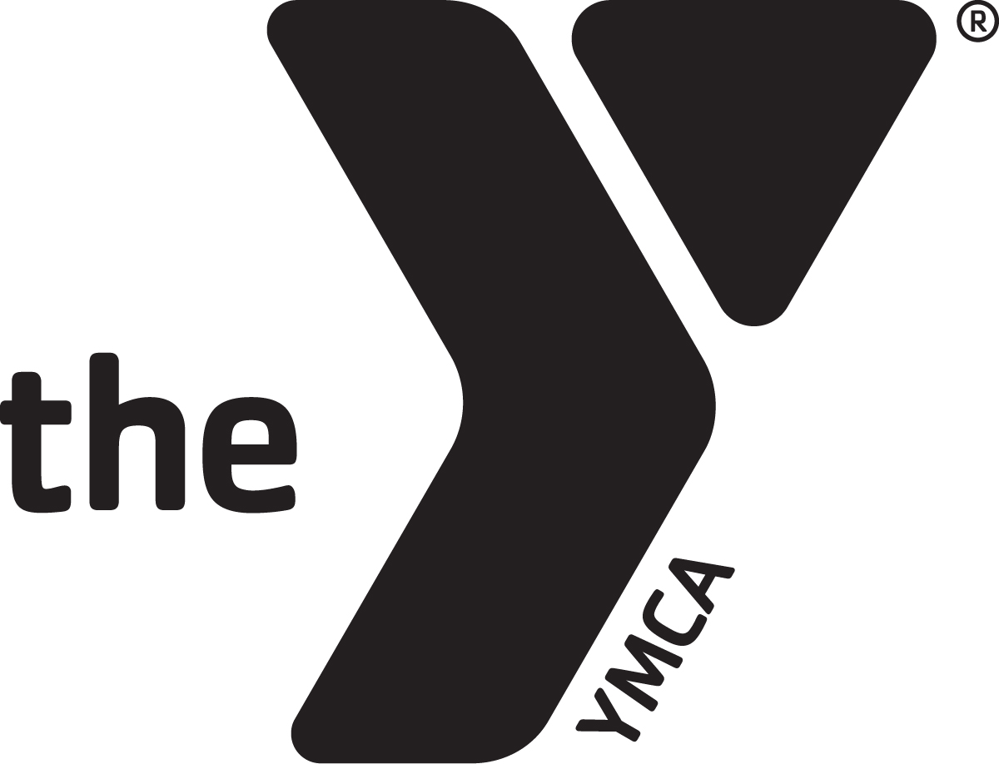
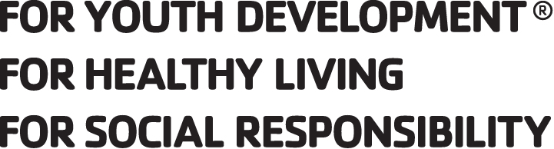

ASHLAND YMCA PRESCHOOL

Welcome to the YMCA Preschool! The registration packet has several important documents that must be completed in full for your child to participate in our program. Be sure to answer each question completely, no matter how repetitive they may seem. ALL forms, fees (including outstanding bills) and information MUST be complete before your child can be accepted. The completed packet needs to be returned a minimum of 48 hours before the intended start date. If the form does not apply to your child, please put your child's name on it and sign with some indication that it does not pertain to you. To receive the member price, you MUST have proof of membership or Partner with Youth eligibility. The registration fee is $25 dollars. The registration fee is non-refundable. After completion of the registration materials, make arrangements with the administrator to review your paperwork and the registration process will be finalized at that time. You will receive updates by way of email about important dates and materials, so please be sure to include an email address for me to send things to. I promise I will not sell your information or give it to anyone without your consent. If you have any questions, please feel free to contact me. I am so excited for our new year to begin and look forward to meeting all of your families! In August or your date of registration completion, you will receive an Ages and Stages Questionnaire to complete and return on the first day of school. If you have any further questions or concerns do not hesitate to reach out, use the phone number or email address listed below.

Most sincerely,
Christie Krumlaw
Christie Krumlaw
Ashland YMCA Preschool Coordinator
ckrumlaw@ashlandy.org
419-289-0626

PLEASE NOTE: The fees for families attending All Day Care account for breaks and snow days, that amount has not been accounted for in the half day or full day preschool prices. If you attend Full Day Preschool and will need care on these days there will be a $30 and advance notice needed. If you show up the day of, without previous arrangements, it will cost an additional $10

Ashland YMCA Preschool Registration
School year enrolling_2021/2022_

Will your child attend kindergarten in the 2022/2023 school year? ___YES___NO
(must be 5 by no later than September 30th for Ashland, Black River and Wooster and August 1st for Hillsdale, Mapleton, Ashland Christian, Crestview, Loudonville, and Northwestern, June 1st for St. Ed's)

Is your child a member of the YMCA___YES___NO Expiration Date________

Your child will attend ________________________school system when they enter kindergarten

Child's Full Name____________________________________________________
(FIRST, MIDDLE AND LAST)

Birthdate_________________ Age of child upon enrollment________

Address__________________________________________________

City ____________________________________ Zip_______________

Email Address_____________________________________________

Cell Phone for Alerts________________________________________

Mother/Guardian___________________________________________

Phone(home)________________________(work)________________

Father/Guardian___________________________________________

Phone(home)________________________(work)________________

Preschool hours are 8:30-11 or 8:30-3. Preschool follows the Ashland City School schedule. To be considered for care over holidays or snow/delay days you must sign up for All Day Care. Full Day Preschool may attend with an additional fee that is stated later in the information.
**A non-refundable registration fee of $25 must accompany this form. You must have a membership to receive member pricing. **

Child's Name___________________________________

Days and Times:
Mon___________Tues___________Wed__________Thur__________Fri__________ IN/OUT IN/OUT IN/OUT IN/OUT IN/OUT

ALL DAY CARE (includes Preschool) 6:30am-6pm
 | Member | Non-member | Total
5 all day | $535 | $650
4 all day (Mon-Thu) | $445 | $560
3 all day (Mon, Wed, Fri) | $355 | $485
2 all day (Tue, Thu) | $315 | $445

FULL DAY PRESCHOOL 8:30am-3pm
 | Member | Non-member | Total
5 all day | $425 | $485
4 all day (Mon-Thu) | $355 | $410
3 all day (Mon, Wed, Fri) | $290 | $350
2 all day (Tue, Thu) | $250 | $305

Will your child require a nap on the days they attend ______yes _____no (please check one)

HALF DAY PRESCHOOL 8:30am-11am
 | Member | Non-member | Total
5 day AM/PM Preschool | $240 | $350
4 day AM/PM Preschool | $200 | $275
3 day AM/PM Preschool | $170 | $250
2 day AM/PM Preschool | $150 | $220

Total to be paid MONTHLY_______________

Parent Signature _____________________________ Date_______

_____(Initial) I would like to have my payments paid through Scheduled Payments and will file proper paperwork with the Preschool Coordinator. Payments will be taken the first of every month. I DO NOT HAVE TO BE A MEMBER TO USE THIS OPTION.

Financial Agreement
I agree to pay the Ashland YMCA Preschool the stated amount of tuition indicated for my child's care. Tuition is due September through May. A two week notice of withdrawal is required from preschool. To receive the member rate, I understand that my child must be an active member. Tuition is due monthly by the first week of each month, and a late fee of $20 will be assessed after the 10th of that month. If I am a JFS family I will have all proper paperwork completed before attendance begins and will keep up on my entries to receive these benefits. If I am more than 10 days behind on entries, I agree that I will self-pay for the time that has been used at the rate of $30/day.

*Parent/Guardian Signature _____________________________Date______

Administrator Signature _______________________________Date_______

Swimming, Gymnastics and Walking Field Trip Permission
TBD by COVID-19 REGULATIONS AT THAT TIME
Please check all that apply:
____My child has my permission to participate in the YMCA swimming program. The center will have two supervising staff and a certified life guard on duty at all times.
____ My child also has permission to participate in gymnastics lessons and activities. Children will be supervised and assisted during lessons, to maintain a safe and healthy environment.
____The YMCA preschool will go on walking trips, weather permitting, within a two-block radius. Children will be taught safety while on the walking trips, under the supervision of classroom staff. During walking trips children will not be near water more than two feet.
*Parent signature _______________________________Date____________ Parent notes or relevant information regarding these activities: ______________________
_______________________________________________________________________

I do not give permission to participate in any of the activities listed above
*Parent signature _______________________________Date____________

Assessment Permission and Authorization
The children will be assessed at least three times throughout the school year for academic gains and will do developmental assessments using Ages and Stages Questionnaire and other methods a minimum of once a year. I give permission for the teachers to perform such assessments and share the information with us and the school they will attend upon leaving the Ashland YMCA Preschool.

*Parent/Guardian Signature _____________________________ Date______

Ashland Family YMCA Preschool
Emergency Pickup Information
Persons authorized to pick up child from school other than custodial parent: Must name AT LEAST one.

Child’s Name _____________________________________________________________

Child’s birthdate _________________ Email_____________________

Address _______________________________________________

Parent who should be contacted FIRST (name of parent) _____________ NUMBER to be called during the day _________________

Person to contact SECOND/relationship/phone

______________________________________________
Authorized pick up individuals:
Name Relationship Phone

1.____________________________________________________________

2.____________________________________________________________

3.____________________________________________________________

4.____________________________________________________________

Roster Permission
The State of Ohio requires preschools to have a roster of all children enrolled in preschool. HOWEVER, the only thing I need to have on it is the child’s name. I make a roster of parent’s names, phone, address and email for your convenience. You are welcome to use this info to invite children to play or for party invitations. We do not use it to solicit or harass our families. You can choose what information you wish to share; all or just a few things

Pick what you wish to be listed on roster:

_____ Mom’s name ______ Dad’s name _____ Email _____Future School System

_____ Address ______ Phone _____ Child’s birthday

Handbook Acknowledgment
Parents, after reading the handbook, please sign and return this page to the director. This is due before the child attends the center. Please feel free to ask the director any questions about the policies in the handbook.
I acknowledge that I have received a copy of the parent handbook for the Ashland Family YMCA Preschool. I agree to follow all policies outlined within.

__________________________________ _________________
Signature of parent/guardian Date

___________________________________ _________________
Signature of parent/guardian Date
*The handbook is on our website to read. If you would like, a hard copy can be provided upon request.

Photo Release
The Ashland YMCA Preschool shares photographs of classes and participants on our gethomeroom.com web-site to show families what we do all day. We would like your permission to use photographs of our day on our website. If you do not grant permission, please indicate this below.

I give the YMCA permission to use photographs of my child/children on the website.

X _______________________________________ Date _________

OR
I DO NOT grant permission and the YMCA may not use my photos on the website.
X _______________________________________ Date_______

Ashland Family YMCA Preschool
Supply list for the beginning of the year
We NEED:  Silverware (Spoons especially)  5 oz cups  Bowls  Paper Plates  Napkins  Tissues  Paper Towels | If you WANT:  Markers  Dry Erase Markers  Colored Pencils  Pencils  Crayons  Glue Sticks  ** These items are not necessary but if your child would like to bring school supplies in these are the things we would use.
Once the school year begins these supplies will be refilled by the program

YMCA PRESCHOOL T-SHIRTS

Every school year you may purchase matching t-shirts to wear on special days at our school. The shirts are $10.00 and cover the cost of the shirt and the printing. Please send this in with a check for $10.00 made payable to the Ashland YMCA. This is not required of the children but we will have days where they will be given the opportunity to wear the shirts as a school. Please write a separate check and give to administration for proper record keeping. This is only an option to buy until school begins in September.
----------------------------------cut here------------------------------------

Child___________________________________________

My child will need a CXS______CS ______CM______CL______

For office use only
Payment received date____________________ | T-shirt delivered  date___________________

Preschool Scheduled Payment Authorization/Agreement

I ___________________authorize my bank to make payment to the Ashland YMCA by method indicated below, and post it to my account for my child's care at the Ashland YMCA Preschool. This is for: (please circle the appropriate category and amount of days.)
ALL DAY CARE | 2 DAYS | Member
FULL DAY PRESCHOOL | 3 DAYS | Non-member
HALF DAY PRESCHOOL | 4 DAYS
 | 5 DAYS

Amount Paid______________
Checking_____ Bank Name_________________________________
NOTE: for checking account authorization, a voided check is needed
Account #___________________________ Routing #___________________________
Credit Card_____ Mastercard____ Visa____ Discover____ Other____
Expiration Date____/_____(For credit card payments)
Address__________________________________________
City ______________ State_____ Zip_______
Home Phone____________ Cell Phone____________
I understand that I am in full control of my payment, and if at any time I decide to make any change or discontinue the service, I will call or write the above company. A two-week notice is needed to make any changes. Change of payment will not affect other provisions and terms of my contract.

Signature ______________________________ Date_______
Staff Witness ___________________________ Date_______
Scheduled Payment Agreement
I UNDERSTAND that when enrolling in the Ashland YMCA Preschool using Scheduled Payment as the method of payment, I am committing to a nine-month period of time for the school year, which will be taken out of my checking, savings, or credit card account monthly on the first of every month. I also understand that any outstanding payments not received within 60 days will be turned over to RBC Collection agency. Returned items or denied transactions will have a fee of $15.00 charged. Initials____

YMCA PHOTO/AUDIO VISUAL/NARRative RELEASE
I am 18 years of age or older and, if not, my parent or legal guardian has also provided their consent by signing below.
Consent & License. For my participation in activities to be conducted by the National Council of Young Men’s Christian Associations of the United States of America (“YMCA of the USA”) or any of its chartered member associations in the United States (collectively “the Y”), and collaborating third parties, I consent, now and for all time, to the making, reproduction, editing, broadcasting or rebroadcasting of:
- video film or footage of me,
- sound track recordings of me
- photo reproductions of me
- any narrative account of my experience
My consent includes a perpetual license to the Y and collaborating third-parties for the use of the above materials for publication, display, sale or exhibition in promotions, advertising, education and commercial uses. Use includes reproductions in any form and media currently existing or later conceived, adaptations and/or revisions, throughout the world in perpetuity.
I understand and agree there may be no additional compensation for this license, and I will not make any claim for payment of any kind from the Y or collaborating third-parties. I may, or may not be, identified in such licensed uses; however, my name will not be used to endorse any particular products or services.
Ownership, Confidentiality, and Shared Use. With respect to any of the above uses, I further agree:
- All works shall belong to YMCA of the USA;
- The Y has no duty of confidentiality regarding any licensed uses;
- YMCA of the USA shall exclusively own all known or later existing rights to the uses throughout the world;
- The Y and collaborating third-parties may use any video film, footage, sound track recordings and photo reproductions of me and/or my narrative account for any purpose without additional compensation to me.
Release from Liability. I agree that my consent is irrevocable. I hereby release and discharge The Y and collaborating third-parties, from any and all claims, actions, lawsuits or demands of any kind arising out of my consent, license grants, uses, or the shared uses of any works or materials referenced herein.
Signature: ____________________________________Date: __________________
Printed Name: ________________________________Age: ________
Address: ____________________________________________________________
___________________________________________________________________
I am the parent or legal guardian of _______________________________________. I hereby consent and grant the licenses detailed in the foregoing on behalf of my minor child.
Signature of parent or legal guardian: ______________________________________
Printed name: ______________________________________________________

Support Identification

In an attempt to provide a supportive learning environment and promote positive behaviors, we recognize supports and accommodations enable children to reach their fullest potential in a safe environment. Therefore, we have identified several types of strategies that may be helpful to participants. We also recognize that the introduction of these strategies may impact our staff to child ratio and the well-being of all the children in attendance.
For all applicants, we are documenting and reviewing supports identified by the parents/caregivers as they enroll their child in the program. With this information we determine if we are capable of providing a safe and effective learning environment, we make decisions on whether we are the appropriate placement for each child who desires to enroll in the YMCA program.

*Child's Name _________________________________________
_____needs no supports at this time. Please sign below.

_____needs the following supports and I have the documentation needed to receive these supports. Please mark appropriate supports and sign below.
_____Behavioral Supports _____Health Supports
_____Communication Supports _____Instructional Supports
_____Natural Supports _____Social Supports
_____Transition Supports _____Universal and Accessible Physical and Program Design Supports

If you have information on recent assessments in the areas listed below that would help identify appropriate strategies. Please provide documentation and sign below.
_____Behavioral Supports _____Health Supports
_____Communication Supports _____Instructional Supports
_____Natural Supports _____Social Supports
_____Transition Supports _____Universal and Accessible Physical and Program Design Supports
*Must be documented by a professional in written form prior to attendance and implementation. Please see next page for support explanation.

___________________________________ ____________________
Parent/Care Giver Signature Date

Support Definitions

Behavioral Supports- intended to minimize challenging behaviors. These behaviors are intended to communicate and when attempting to eliminate behavior child's frustration may be magnified. Professionals need to pinpoint what is being communicated and what environmental factors are contributing to the behaviors. When it is known what is communicated and contributes to the behavior positive support can be implemented to eliminate the risk of behaviors being displayed.

Communication Supports- intended to ensure the child understands thoroughly what is expected. Each intervention must be clear and purposeful in communication through verbal, nonverbal and kinesthetic feedback. Professionals will willingly communicate expectations, requests, and acceptable behavior parameters to create motivating and safe environments. The communication the child receives will assist them in being able to sort out what is important and respond to what they hear.

Health Supports- intended to accommodate physiological well-being and function at their maximum capacity. The use of proper diet, rest, pain management and sunlight exposure is managed. Use of quiet spaces to help regain composure as well as medications and physical activity levels will be monitored to support the child.

Instructional-leadership Supports- intended to support engagement. Professionals will plan and structure predictable environments to focus on strengths and goals.

Natural Supports- intended to be support from a family member whose preferences support the child. Support occurs when there are balanced meals and there are designated areas for appropriate choices.

Organizational Supports- intended to be supports given by collaborative team of professionals and care givers. An inclusive plan will be developed to support the child and a zero-tolerance approach will be taken to implement the support.

Social Supports- intended to help the child gain social competence, become aware of social expectations, gain information through interactions and exchange feelings during an experience.

Transition Supports- intended to help the child transition from one location to another or to another program. This support can also be used to move from one activity to another within the classroom.

Universal Design and Program Supports- intended to assist in designing structures for all children regardless of ability. Barriers are minimized and access is maximized by, for example, signs and checklists to cue children. Multiple engagement opportunities are offered to include children with a range of diverse abilities and skills.

Child's Name____________________________________ Birthdate_________
Future School System_______________________
Will attend Kindergarten in the year 20__
Child Information List
_____Registration Form & Fee ____ cash____ check____ pd date______
_____Medical Statement Expiration Date_______ Completed by_________
_____Child Enrollment/Health Info & Allergies (pg. 1&2)
_____Page 3 & Medical Physical Care Plan
_____Family Information Sheet
_____Financial Agreement
_____Swimming, gymnastics, local walking permission
_____Assessment Permission
_____Handbook Acknowledgment
_____Photo release for Homeroom
_____Pick up Information
_____Roster Permission
_____T-shirt Order
_____Scheduled Payment Form
_____YMCA Photo Release
_____Support Identification

Registration Completed when: (Office Use Only)
____Physical List
____Photo Release _Y / N__ Homeroom _Y / N_YMCA
____Roster
____Scheduled Payment _Y / N_
____Daxko
____Medical Alert
____Attendance
____Email List
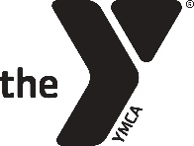

Family Information For Step Up to Quality
PRESCHOOL

Child's Name (Last) | (First) | Nicknames (if any)

By providing complete information about your child, you will be assisting staff in creating a positive experience for him/her while in care. List any information about your child's habits, abilities, or personality that you feel will be helpful to the staff while caring for your child

Who is in the child's immediate family?

Who lives at home with the child?

What is the primary language spoken in your child's home?

Are there any special family arrangements, such as shared parenting, living in two homes, or custody specifications, divorce, new home, death or birth of a family member, friend or pet.

Are there any cultural or religious practices of your family we should be aware of? (Dietary restrictions, clothing, etc)

Has your child had a previous care arrangement? __Yes __No (if yes circle one: Center based, in home, with family, with parents, other_______________)
Are there foods your child dislikes/ likes that we should be aware of? __Yes __No

Likes | Dislkes

Are there any foods that your child should not be fed? (allergies, culture, religion based) Licensing documentation be completed for children with food allergies and/or dietary restrictions __Yes __No

Describe your child's personality and behavior

Are there things that frighten your child? If so, how does he/she react and what do you do to comfort him/her?

Other comforting techniques you may use?

What can cause your child to be angry or frustrated? How do you respond?

What is the discipline policy in your home?

Does your child nap? __Yes __No

What is your child's mood upon waking up? | How long does your child nap at home?
Does your child have trouble sleeping? | Does your child need something to comfort them while sleeping?

Does your child need assistance using the toilet? How do they let you know when they need to use the toilet? (words, gestures, signs)

What might you and/or your child be anxious about as he/she starts in this program?

What are you and/or your child excited about as he/she starts in this program?

What are your expectations of this program?

Any other information that would be helpful for the staff caring for your child to know?

Parent Signature | Date
JFS FORM 0511

